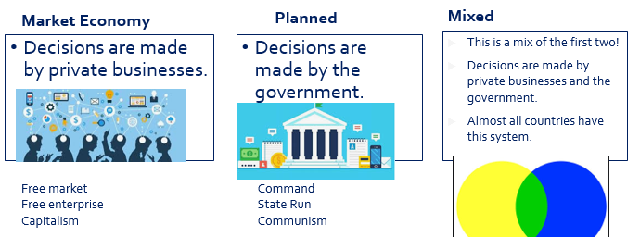
Unit 1
1.1 Scarcity
Resources
What is scarcity
4 types of resource: Land labor capital enterprise
Resources are used to satisfy our wants
limited resources, unlimited wants
The fundamental economic problem
Macroeconomics vs Microeconomics
Market Economy, Planned Economy, Mixed Economy
Incentives
Positive = can be right or wrong eg. Dogs can fly = wrong. Dogs have 4 legs = right
Normative = opinion that can’t be proven right or wrong. eg. Dogs are amazing.
Positive vs Normative economics

1.2 Opportunity Cost, PPC
Next best opportunity foregone when we make a decision
Opportunity cost definition
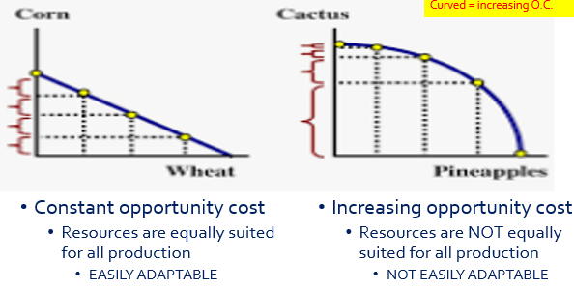
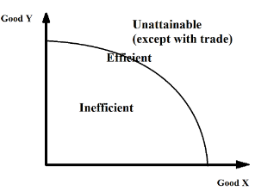
The PPC
Graphical Representation
Tradeoffs / Opportunity Cost
Why only two goods?
Efficient, inefficient, unattainable
Pareto Improvement
Efficient in production vs efficient in allocation
Increasing vs constant opportunity cost
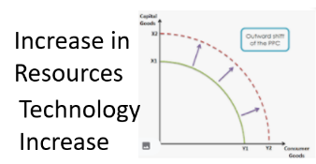
Shifting the PPC
1.3 Comparative Advantage and Gains from Trade
Adam Smith said that countries should specialize in what they have absolute advantage in.
David Ricardo said that they should really specialize in what they have comparative advantage in.
Specialization and Adam Smith
Abs Adv: who can produce more
Compar Adv. = lower Opportunity Cost

Absolute Advantage
Comparative Advantage (David Ricardo)
Gains from trade
Can consume outside of PPC, without changing the PPC at all.
Input Based Questions:
eg. labor hours, electricity used, resources used, capital used
Abs Adv: the smaller number
Comp adv: Reverse the OC calculation

Output Based Questions:
OC, Opportunity Cost = what you give up / what you gain = the ‘other good’ / the good you are looking at.

How to do these questions
Output based
Input based
Terms of trade
1.4 Demand
The benefit that people receive from something.
Higher Utility = You will pay a higher price (willingness to pay)
Utility
All buyers and sellers together.
What is a market
Shows the relationship between price and quantity demanded by consumers.
A demand schedule
Negative relationship between price and quantity.

Law of Demand
Income effect, substitution effect, diminishing marginal utility

Three reasons for slope of demand
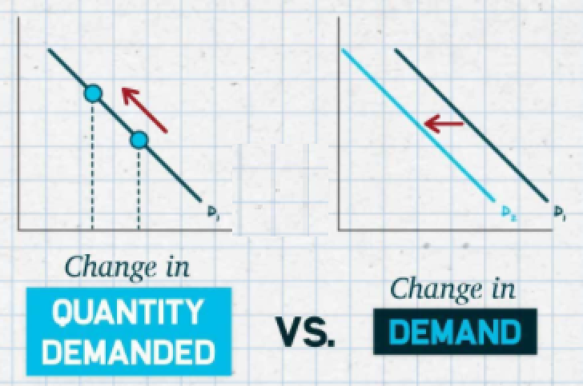
Two ways to look at demand
Shifters/Determinants of demand
1.5 Supply
Positive relationship between price and quantity.

Law of supply
Two ways to look at supply
Shifters/Determinants of supply
1.6 Market Equilibrium, Disequilibrium and Changes in Equilibrium
Shortage/Surplus
Change in Equilibrium
Double Shift Rule
Double Shift Rule: If both demand and supply shift, either price or quantity will be indeterminate.

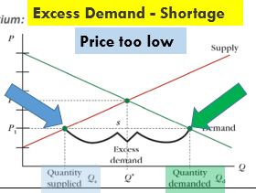
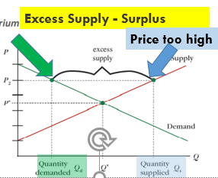

Unit 2

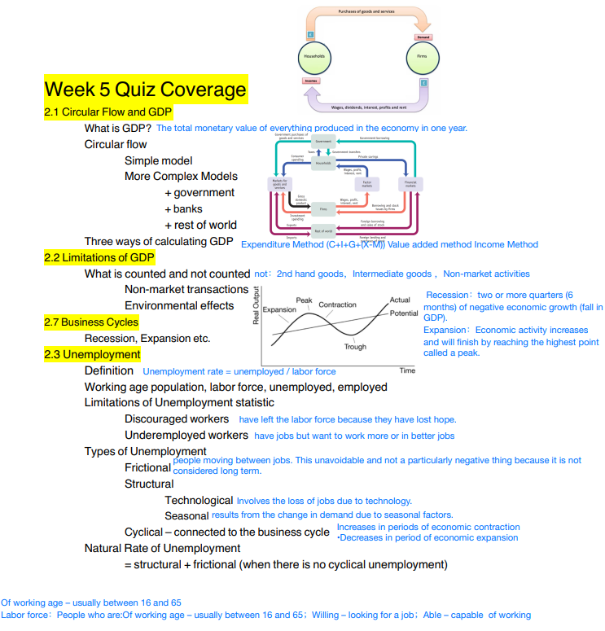
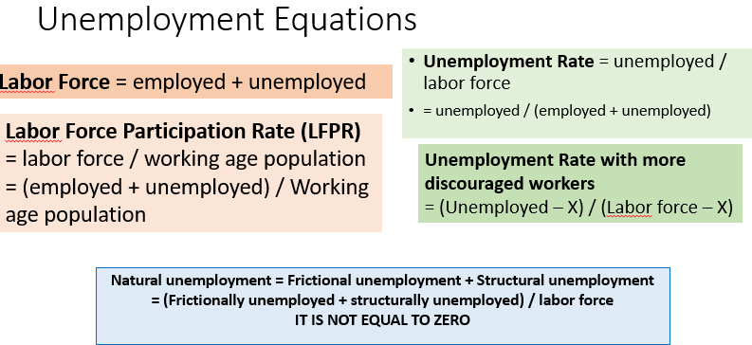
2.4 Price Indices and Inflation
price level (price of all goods and services) increases, value of money decreases
What is inflation?
Market Basket_{new} / Market Basket_{baseyear} x 100
CPI
Changes to quality of goods (CPI overestimates inflation), Substituting for other goods (overstates), changes to basket (over/understates)
Problems with CPI
GDP Deflator
Shoe Leather: Having to change money to other assets – time and effort
Menu: Having to change listed prices on menus, billboards etc.
2.5 Costs of Inflation
Menu Costs, Shoe Leather Costs
Unit of account – using money to measure the value of things
Wages lose value, savings lose value, loss of unit of account
Fisher Equation: Real interest = Nominal interest - inflation
Borrowers gain, lenders lose
2.6 Real v. Nominal GDP
Real = adjusted for inflation
Real = Adjusted for Inflation, Old Prices x quantity
Nominal = not adjusted for inflation, New Prices x quantity

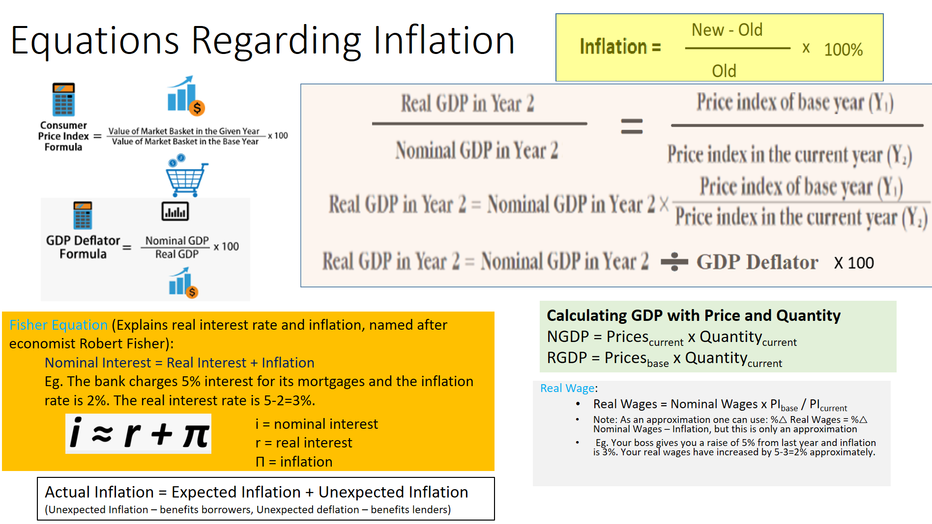
2.7 Business Cycles
Recession, Expansion etc.
Output Gaps
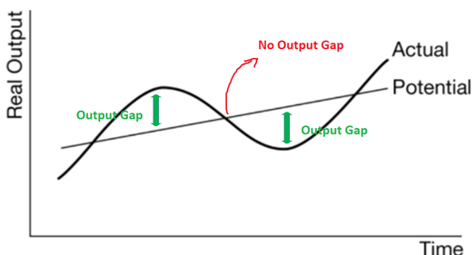
Unemployment
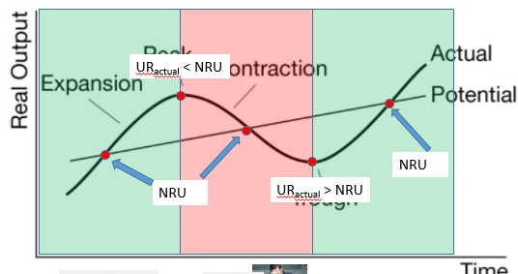

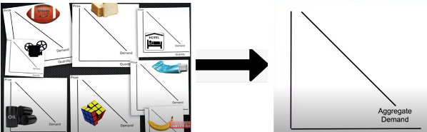
Unit 3
3.1 Aggregate Demand (AD)
Axes are different: P → PL, Aggregate Price Level
Q → Real GDP, Real Output, Y
All market demand curves added together
Three reasons why it slopes down
1. Interest Rate Effect 2. Wealth Effect 3. Foreign Trade Effect
Sticky wages/resource costs – prices don’t change because of contracts, mental resistance, efficiency wages
C+I+G+(X-M)
3.3 Short-Run Aggregate Supply (SRAS)
upward slope = +ve r’ship between PL and Output. Wages stay the same even when selling price of products changes, so profits/output increases/decreases
Shifters of SRAS / Short Run Supply Shocks
Sticky wages – causes upward slope
3.4 Long-Run Aggregate Supply (LRAS)
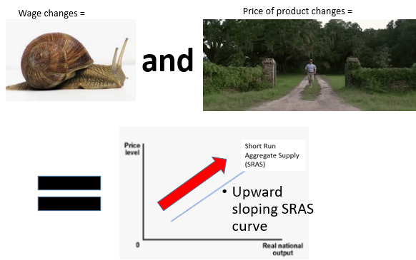
Shifters of LRAS / Long Run Supply Shocks
Connection to the Macroeconomy – PPC, Trend Line Growth
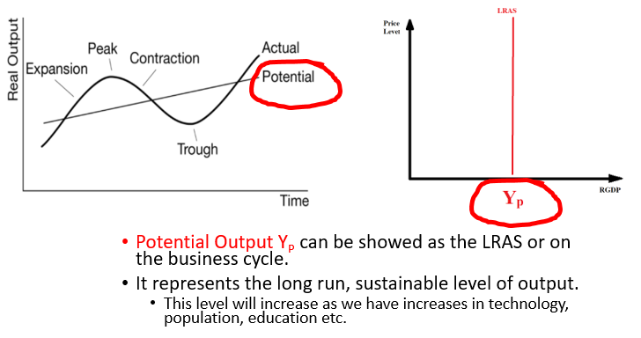
LRAS moves to right:
permanent increase in technology or productivity or resources
3.5 Equilibrium in the Aggregate Demand–Aggregate Supply (AD–AS) Model
AD=SRAS=LRAS
Long Run Macroeconomic Equilibrium
3.6 Changes in the AD–AS Model in the Short Run
AD=SRAS
Short Run Macroeconomic Equilibrium
Output Gaps
Negative – Recessionary Gap, Deflationary Gap, Stagflation (SRAS decreases)
Positive – Inflationary Gap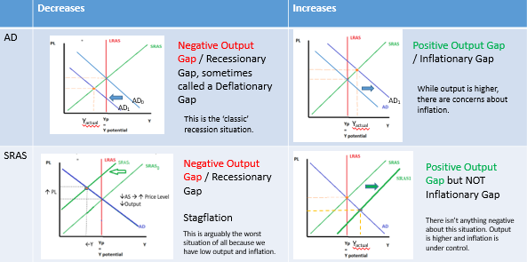

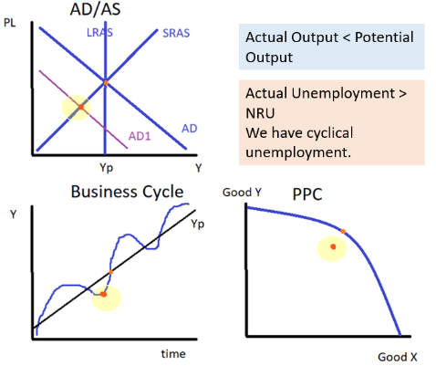
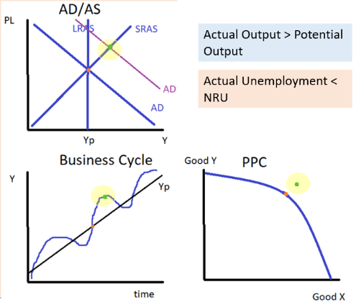
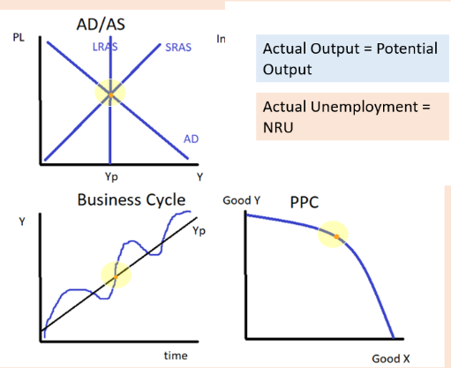

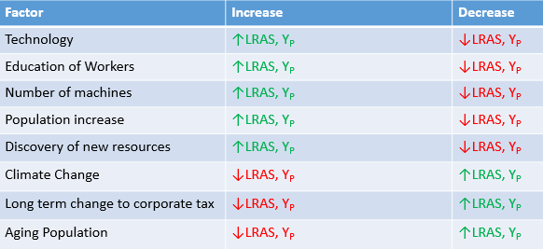
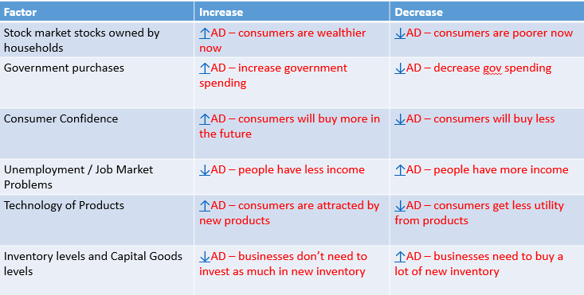

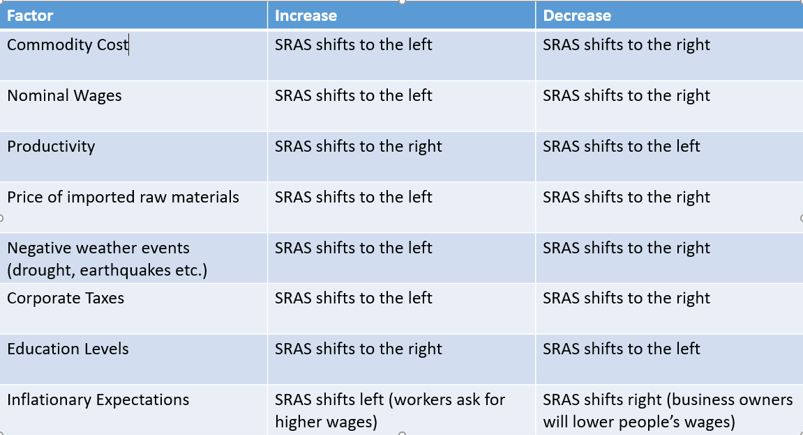
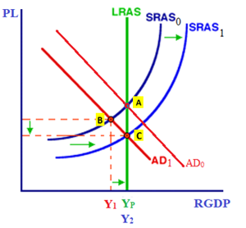
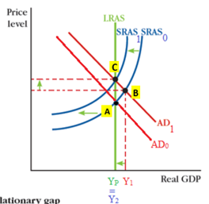
Negative Output Gap Self Adjustment

Positive Output Gap Self Adjustment

3.7 Long-Run Self-Adjustment
SRAS Shifts due to resource costs becoming flexible in long run, to return economy to Y_{P}
Long Run Self Adjustment
Classical – economy self adjusts naturally
Keynesian – economy self adjusts but often takes too long so gov should intervene
Classical Economic Thinking vs Keynesian Thinking
3.8 Fiscal Policy (FP)
FP Tools
Gov spending
Gov transfers
Tax
Expansionary – ↑AD, to fight a recession/negative output gap
↑Gov spending ↑Gov transfers ↓Tax
Contractionary - ↓AD, to fight inflation/positive output gap
↓Gov spending ↓Gov transfers ↑Tax
Fiscal Policy – expansionary vs contractionary
Historical context: John Maynard Keynes
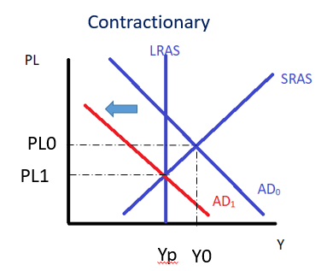
Fiscal Lag – Data Lags, Political Lags, Implementation Lags
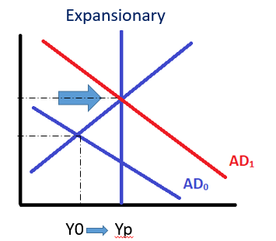
Keynesian Aggregate Supply Curve
Horizontal section has ‘space capacity’ (unused resources).
Keynes believed this shape meant Fiscal Policy could help the economy a lot when in a recession without causing inflation.
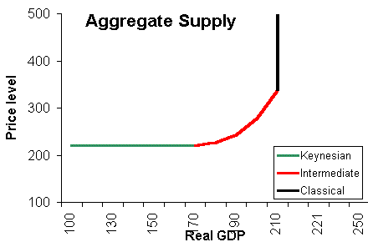
Fiscal Lag
Data lags – economic data takes time to collect and analyse, so information is not completely up to date
Political lags – political disagreement and decision making takes time
Implementation lags – fiscal spending projects such as building infrastructure, or military spending are not immediate

3.9 Automatic Stabilizers
Discretionary Fiscal Policy (human decision) vs. Non-discretionary fiscal policy (tax and social security)
Two Types of Fiscal Policy

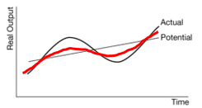
Effect on the business cycle
Discretionary Fiscal Policy/Automatic Stabilizers = tax, social security payments
Recession: ↓Tax ↑Social Security →↑AD
Inflationary Gap: ↑Tax ↓Social Security →↓AD
Reduces size of Output Gaps

Discretionary Fiscal Policy = human decisions are made to spend on things such as Infrastructure, Education, Military
The Automatic Stabilizers will ‘smooth’ the business cycle so that the recessions and expansions are less.

3.2 Multipliers
MPC = Marginal Propensity to Consume
MPS = Marginal Propensity to Save
MPS+MPC = 1
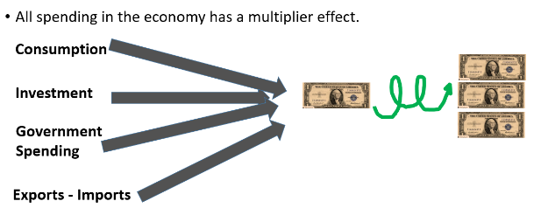
MPC, MPS, Multiplier= 1/MPS = 1/(1-MPC)
Tax Multiplier = -MPC/(1-MPC)
Transfer Multiplier = MPC/(1-MPC)
Full Multiplier: MPC + MPS + MPT (pay tax) + MPM (buy imports)
Spending Multiplier > Tax Multiplier
Therefore, equal size change to tax vs gov spending creates an ↑AD
Most important Equations for Multipliers:
∆GDP = ∆Spending x Multiplier
∆GDP = ∆Tax x Tax Multiplier
∆GDP = ∆transfers x transfer multiplier

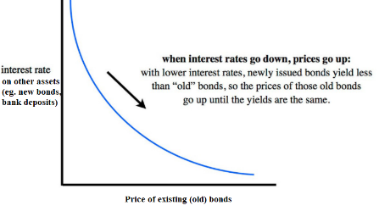
Unit 4
When IR↑, existing bonds become less attractive (because people can put their money elsewhere and earn better interest) and so P_{bonds}↓
4.1 Financial Assets
Bonds
Stocks = part ownership of company. Can receive share of profit but is not called interest.
Debt asset – buyer of bond = lender. Paid back with interest.
Stocks/shares
Mutual funds – you give money to professionals who invest it for you (eg.Pension fund)
Other financial assets
OC = The interest rate you could have earned on less liquid assets.
Opportunity Cost of Holding Liquid Money
4.2 Nominal v. Real Interest Rates
Real Interest = Nominal Interest - Inflation
Fisher Equation
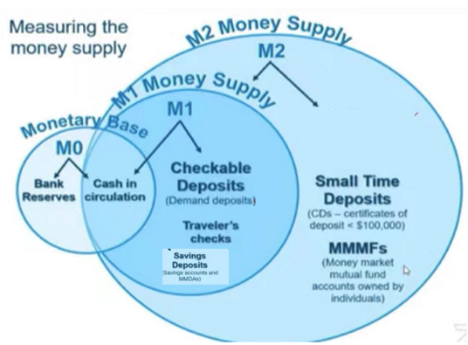
Unexpected inflation/deflation
Unexpected inflation – benefits borrowers
Unexpected deflation = benefits lenders
(With Fixed NIR. With Variable NIR, no one wins/loses.

4.3 Definition, Measurement, and Functions of Money
Money means that we do not have to barter (swap goods for other goods) because money is always accepted. Double coincidence of wants = you want what I have and I want what you have.
Definition: Money is a medium of exchange that is universally accepted.
Definition of Money
Barter Economy and Double Coincidence of Wants
Functions of Money:
1. Medium of Exchange – to buy goods and services
2. Unit of Account – you can measure the value of things eg. A $1000 phone compared to a $100 phone
3. Store of value – you can save money to buy something in the future

Functions of Money
M1 vs M2 Money
M1 – liquid money
M2 – less liquid money + M1

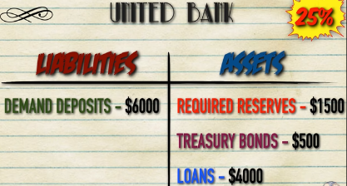
4.4 Banking and the Expansion of the Money Supply
The Central Bank of the US, the Fed
The Federal Reserve
Assets = things of value or will bring money in the future. Liabilities = things that will take away money in the future. Equity = Assets – Liabilities = total value of business.
Balance Sheets / T Accounts
Assets, Liabilities, Equity
Money Multiplier = 1/RRR
Assets = Liabilities + Equity (but we often assume Equity = 0)
How to balance assets and liabilities
Banks keep part of their deposits as required reserves but can lend out the rest (which will increase the money supply)
Fractional Reserve Banking System
Why max ∆Loans and Money Supply may not occur:
1.Consumers hold extra cash
2.Banks keep excess reserves
3.Low demand for Loans

∆Loans = Loan_{original} x 1/RRR
∆Deposits = Deposit + Loan_{original} x 1/RRR

∆Loans
Required Reserves, Excess Reserves
Excess Reserves – can be used to create new loans.
Banking System Money Multiplier
Buying Bonds, Selling Bonds
The Gov/Central Bank can buy/sell bonds to increase or decrease the MS. Buy Big, Sell Small
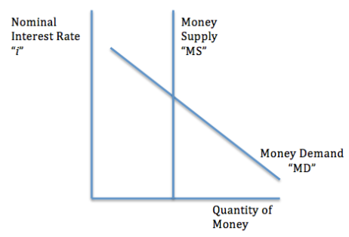
MD Shifters – price level, AD, Wealth, banking convenience

4.5 The Money Market
People desire liquid money for: Transactions, Asset, Precaution

Holding Liquid Money

Money Market Demand
Cost of holding liquid money
MS = Vertical – set by the Fed, No relation between interest and quantity
= interest that you gave up

Money market Supply
Nominal interest because a short term market and future price level is not considered.
Nominal Interest Rates
Effect of increase/decrease money supply
Increase MS = expansionary monetary policy
Decrease MS = contractionary monetary policy
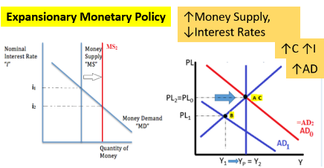
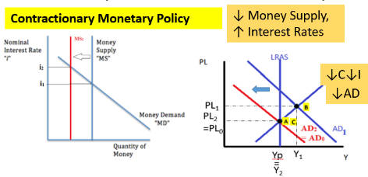

4.6 Monetary Policy
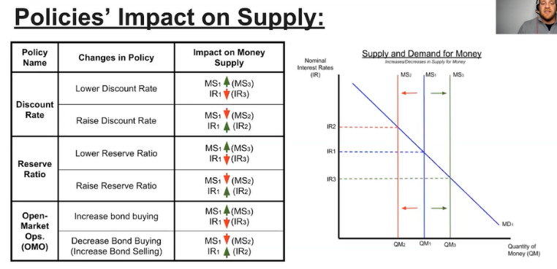
Expansionary vs Contractionary
3 tools of monetary policy
Buy = big (increase MS)
Sell = small (decrease MS)
Open Market Operations (OMO)
Discount Rate/Federal Funds Rate
Required Reserves

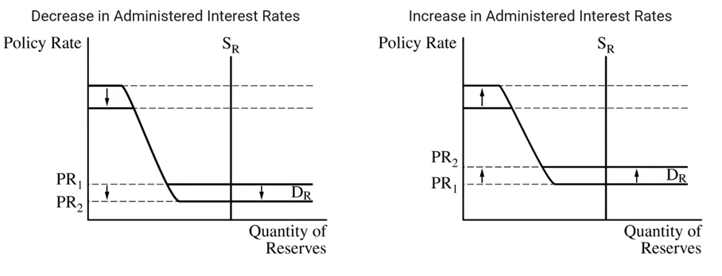
4.6 Ample Reserves Monetary Policy
Expansionary MP (lowering IR)
Contractionary MP (increasing IR)
Limited Reserves Economy
Discount Rate
(top flat part)

3 Tools of MP can be used
Note: In Ample reserves economy we are on the bottom flat part of the graph. Therefore IOR = PR

(OMO, RRR, Discount Rate)
Ample Reserves Economy
Interest on Reserves
(bottom flat part)
Usually IOR = PR

Conditions
Change of MS no longer affects the IR
Ample/Unlimited Reserves in Economy
RRR is at zero
Policy Rate (PR) – in the US, the Federal Funds Rate (FFR), the rate that banks pay when they lend to each other.

Discount Rate (DR) – rate that commercial banks pay to borrow from the Fed.

Interest on Reserves (IOR) – rate that the Fed pays to banks for keeping reserves.

Monetary Policy
Fed can increase/decrease the administered rates
Discount Rate, Interest on Reserves
This affects the Policy Rate

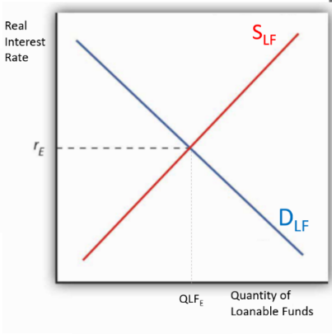
4.7 The Loanable Funds Market
Supply of loanable funds = people wishing to lend and earn interest

Borrowing and Lending

Loanable Funds Demand
Rate of Return/Return on Investment
Supply of Loanable Funds = Public Savings + Private Savings + Foreign Lending

Loanable Funds Supply
Real Interest Rates
Demand for loanable funds = people wishing to borrow

Real Interest Rate used because it is a long term market where inflation matters.
Government Budgets
Tax = Gov Expenditure
Tax < Gov Expenditure
Tax > Gov Expenditure

Balanced Budget
Budget Surplus
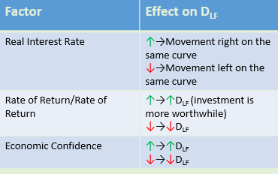
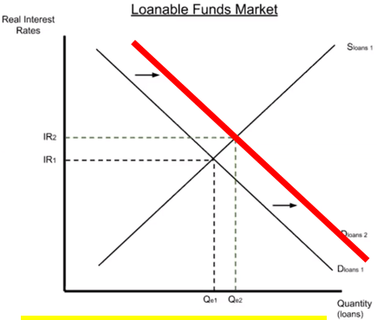
Budget Deficit
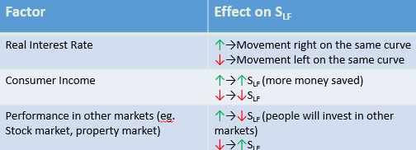
Budget Deficit → ↑D_{LF} because Government must borrow money to pay for expenditure.

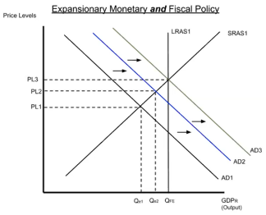
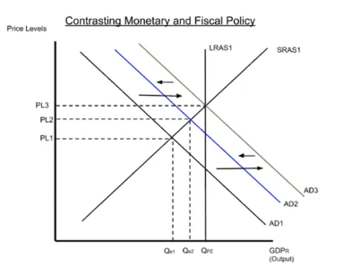
Unit 5
5.1 Fiscal and Monetary Policy Actions in the Short Run
FP and MP can move AD in the same direction
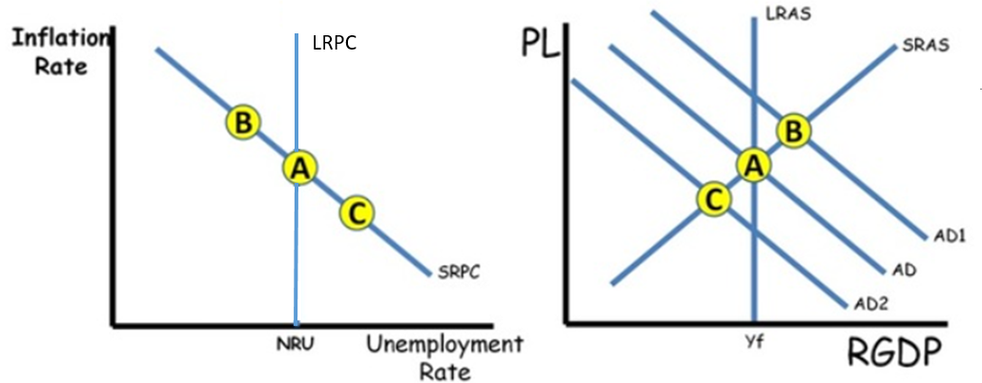
or ‘cancel each other out’

5.2 The Phillips Curve
Relationship between
inflation and unemployment
SRPC
LRPC
Connection to other graphs
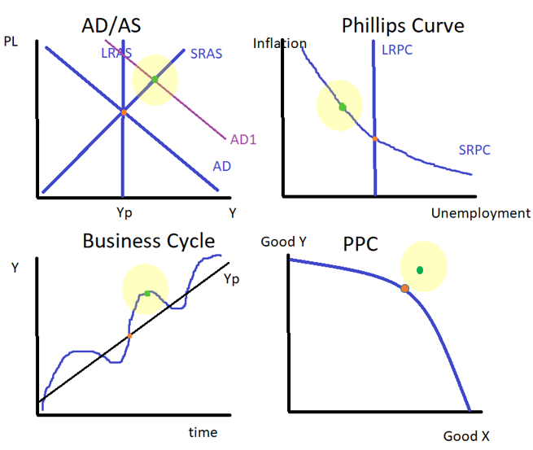
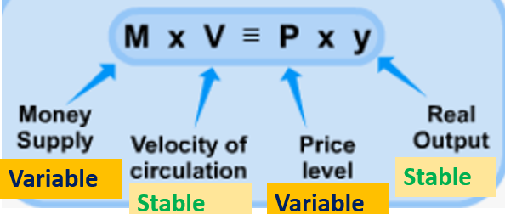
5.3 Money Growth and Inflation
Long Run
Money Neutrality
In the long run, increasing money supply has no effect on Output, Y
(However, in the short run expansionary MP can have an effect on Output, Y)

5.4 Government Deficits and the National Debt
= Government Spending G + Government transfers (social security, unemployment benefits etc.)
Government Expenditure
Budget Deficits, Balanced Budget, Budget Surplus
Debt vs Deficit, Surplus vs Savings
→Neutral Fiscal Policy
→Expansionary Fiscal Policy
→Contractionary Fiscal Policy

Balanced Budget: Tax = Government Expenditure
Budget Deficit: Tax < Government Expenditure
Budget Surplus: Tax > Government Expenditure

Debt, Savings = over multiple periods of time
Deficit, Surplus = for one period, a year

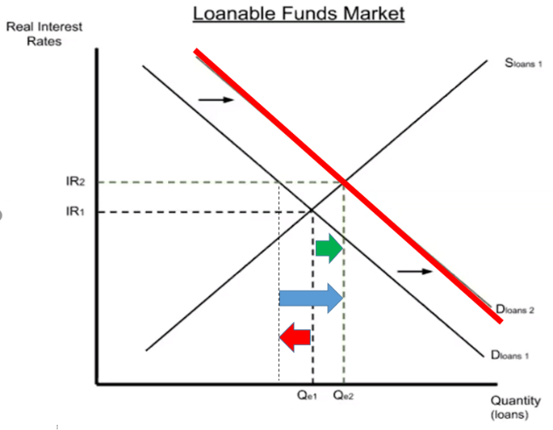
5.5 Crowding Out
Effect of Government borrowing on private investment
Macroeconomic consequences
Expansionary FP / Budget deficit →↑Government borrowing→↑IR→↓Private borrowing→
→↓Investment→↓capital formation and technology→↓economic growth rate

5.6 Economic Growth
Connecting all graphs that show economic Growth
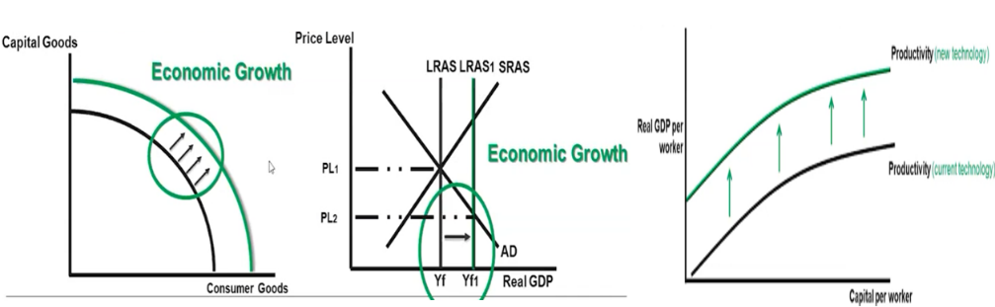
PPC, AD/AS, Aggregate Production Function
Aggregate Production Function

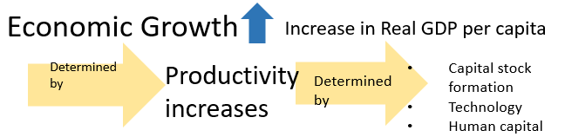

5.7 Public Policy and Economic Growth
Policies and Fiscal Policies designed to shift LRAS to the right.
Supply Side Policies
Gives businesses and people more of an incentive to work hard and earn profit, increasing supply
Lower income tax
Businesses have lower costs to start up and operate, increasing supply
Less regulation
Investment and encouraging investment
Capital
Increases the productivity of workers, leading to higher output per worker, increasing supply
Technology
Human Capital

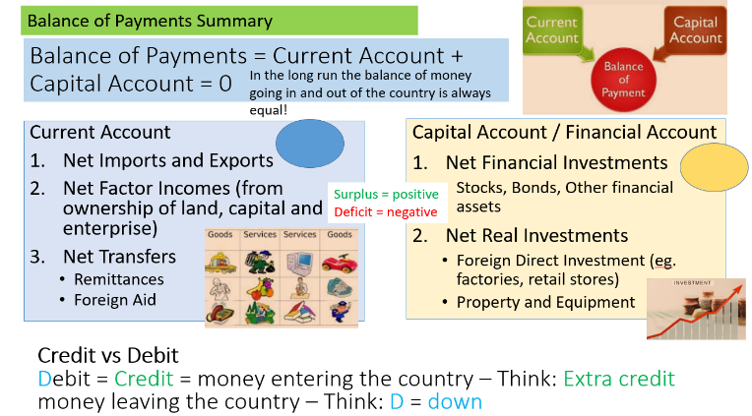
Unit 6
Foreign Direct Investment – companies investing in themselves in another country. Eg. Xiaomi opens a factory in Malaysia.
6.1 Balance of Payments Accounts
The Balance of Payments
Remittances = sending money back home to family etc.

Exchange Rate – the value of Currency A in terms of Currency B. Eg. 1USD = 6.35 RMB, 0.15USD = 1 RMB
6.2 Exchange Rates
Appreciation – the value of the currency increases eg. 1USD = 1.3AUD → 1USD = 1.5AUD
Depreciation
= ↓Purchasing Power → ↓Imports ↑Exports
Eg. Exporters selling to foreigners benefit because their goods are cheaper.

Appreciation
= ↑Purchasing Power →↑Imports ↓Exports
Eg. Tourists travelling to other countries benefit.

What is an exchange rate?
Depreciation – the value of the currency decreases eg. 1USD = 1.5AUD → 1USD = 1.3AUD
Appreciation, Depreciation
Fixed Exchange Rate Regime – the government wants to keep the exchange rate at a certain level and takes action to maintain this level.
Floating Exchange Rate Regime – the demand and supply in the market determines the exchange rate and so it often goes up and down.
Floating vs Fixed Exchange Rate Regimes
6.3 The Foreign Exchange Market
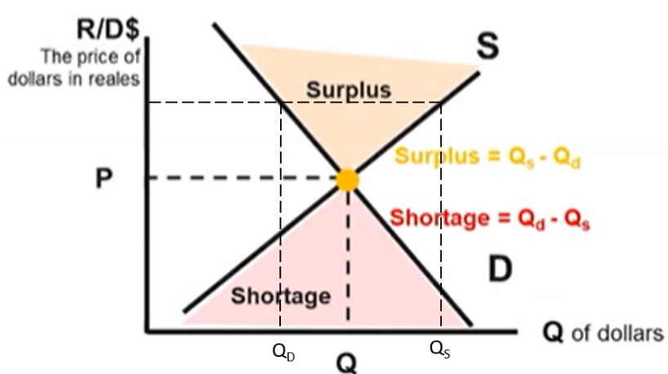
Exchange rate graph
Shifters of demand and supply of currency
Appreciation
Depreciation
∆Demand of Currency A = ∆ Supply of Currency B
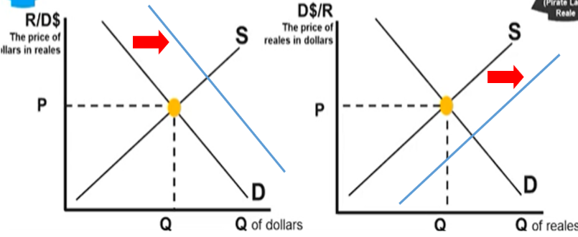
Determinants of Demand AND Supply
Tastes and Preferences
Income Level
Interest Rates
Price Level (Inflation)
Trade Policies (eg. Taxes on imports)
Expectations of Future Exchange Rate

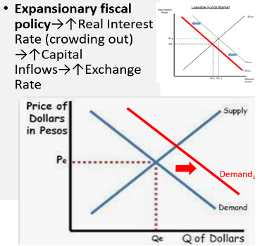
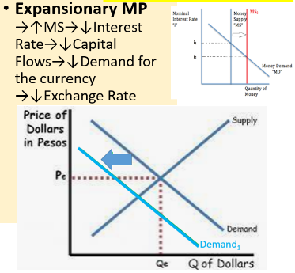
6.4 Effect of Changes in Policies and Economic Conditions on the Foreign Exchange Market
MP Effect on the Exchange Rate
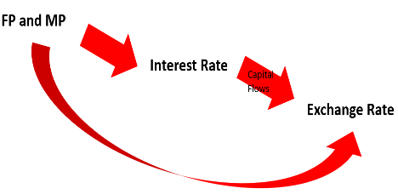
FP Effect on the Exchange Rate

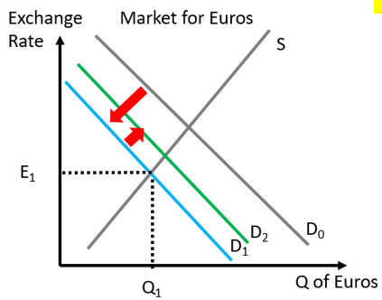
6.5 Changes in the Foreign Exchange Market and Net Exports
↓Exchange Rate →↑X-M (imports more expensive for locals, exports cheaper for foreigners) →↑D_{currency} →↑Exchange Rate?

In many of these questions we should remember that there are many variables affecting each other, however the 1st effect is stronger than the 2nd effect and so the movement in the original direction will still apply.

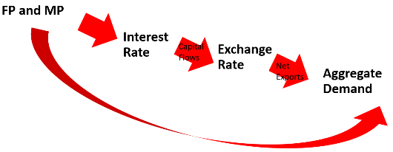
Effect of Exchange Rate on Net Exports and AD

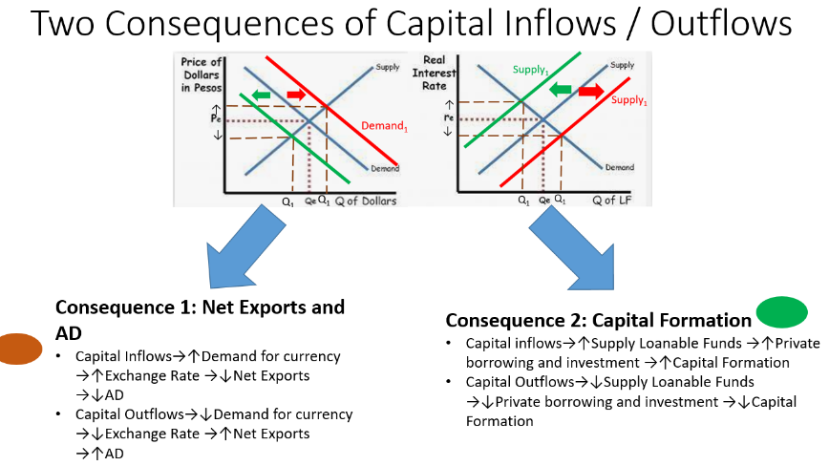
6.6 Real Interest Rates and International Capital Flows
Effect of Capital Inflows/Outflows on:
Net Exports and AD
Capital Formation

